|  |  |  |  |
| --- | --- | --- | --- |
| D | C | B | A |
| 0 | 0 | 0 | 1 |
| 0 | 0 | 1 | 0 |
| 0 | 1 | 0 | 0 |
| 1 | 0 | 0 | 0 |
| 0 | 0 | 0 | 1 |

|  |  |  |  |
| --- | --- | --- | --- |
| D | C | B | A |
| 0 | 0 | 1 | 1 |
| 0 | 1 | 1 | 0 |
| 1 | 1 | 0 | 0 |
| 1 | 0 | 0 | 1 |
| 0 | 0 | 1 | 1 |

|  |  |  |  |  |  |  |  |  |  |
| --- | --- | --- | --- | --- | --- | --- | --- | --- | --- |
|  | Blk3 | Blk2 | Blk1 | Blk0 | Blk3 | Blk2 | Blk1 | Blk0 |  |
| Byte 6 | 1 | 1 | 1 | 1 | 1 | 1 | 1 | 1 | FF |
| Byte 7 | 0 | 0 | 0 | 0 | 0 | 1 | 1 | 1 | 07 |
| Byte 8 | 1 | 0 | 0 | 0 | 0 | 0 | 0 | 0 | 80 |

|  |  |  |  |  |  |  |  |  |  |  |  |  |  |  |  |
| --- | --- | --- | --- | --- | --- | --- | --- | --- | --- | --- | --- | --- | --- | --- | --- |
| *Key_A* | | | | | | *Bits d'accès* | | | | *Key_B* | | | | | |
| *0* | *1* | *2* | *3* | *4* | *5* | *6* | *7* | *8* | *9* | *10* | *11* | *12* | *13* | *14* | *15* | |

aoumnad@gmail.com

*Lecture*

*Ecriture*

*Lecture*

*Ecriture*

*Vcc*

*Ligne*

*Pull-Up*

*+0.5V*

*5V*

*0*

*Ve*

*Vs*

*-0.5V*

*5*

*2*

*1*

*0*

*3*

*4*

*Vs*

*Ve*

*0.5*

*-0.5*

≠≈

*Emetteur*

*Récepteur*

*Transmission de l’octet 11001011*

Bit 0

Bit 0

Bit 1

Bit 1

Bit 2

Bit 2

Bit 3

Bit 3

Bit 4

Bit 4

Bit 5

Bit 5

Bit 7

Bit 7

Bit 6

Bit 6

*11001011*

*Emetteur*

*Récepteur*

*Transmission de l’octet 11001011*

*11001011*

*11001011*

*UART de l'émetteur*

*Convertisseur parallèle série*

*Stop bit*

*Start bit*

*P 1 1 0 0 1 0 1 1 S*

*Horloge*

*Bus du microcontrôleur*

*11001011*

*Convertisseur série parallèle*

*Stop bit*

*Horloge*

*Bus du microcontrôleur*

*Start bit*

*UART du récepteur*

Tx

Rx

Gnd

Tx

Rx

Gnd

*S*

*0*

*1*

*0*

*1*

*1*

*0*

*1*

*0*

*P*

*Signal= 01011010 = 0x5A = 'Z'*

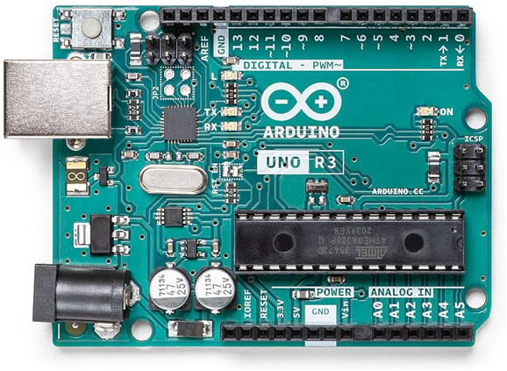

***V***

***Vref=5V***

***N***

**ADC**

***V***

***Vref = 5V***

**ADC**

***N***

2

3

1

0

2.50

1.25

3.75

5.00

0.00

V

N

*Détermination de N par l’ADC*

0.625

1.875

3.125

4.375

Δ

2

3

1

0

2.50

1.25

3.75

5.00

0.00

V

N

*Calcul de V à partir de N*

*V = N * 5 / 4*

δ Δ≈

*3*

*2*

*1*

*0*

*0*

*19.531*

*4.883*

*14.648*

*9.766*

*V(mv)*

*N*

*5000*

*1023*

*4995.117*

Δ

*3*

*2*

*1*

*0*

*0*

*19.531*

*4.883*

*14.648*

*9.766*

*4*

*V(mv)*

*N*

*5000*

*1023*

*4995.117*

*4992.676*

*2.441*

*7.324*

*12.207*

*17.089*

*21.973*

Δ

A

*KA*

B

*KB*

C

*KC*

D

*KD*

|  |  |  |  |  |
| --- | --- | --- | --- | --- |
| A | B | C | D | Moteur |
| 0 | 0 | 0 | 0 | Roue libre |
| 1 | 0 | 0 | 1 | gauche |
| 0 | 1 | 1 | 0 | droite |
| 1 | 1 | x | x | interdit |
| x | x | 1 | 1 | interdit |
| 1 | 0 | 1 | 0 | frein |
| 0 | 1 | 0 | 1 | frein |

|  |  |  |  |
| --- | --- | --- | --- |
| ***ENA*** | ***IN1*** | ***IN2*** | ***Fonction*** |
| *0* | *x* | *x* | *Roue Libre* |
| *1* | *1* | *0* | *Rotation avant* |
| *0* | *1* | *Rotation arrière* |
| *0*  *1* | *0*  *1* | *Arrêt rapide* |

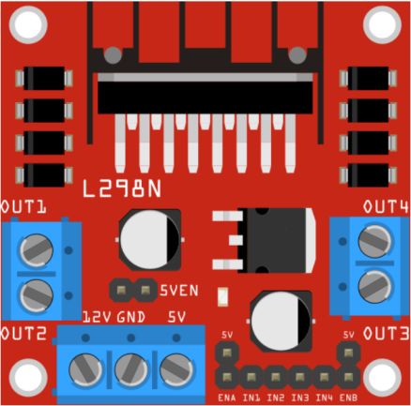

GND



H

T

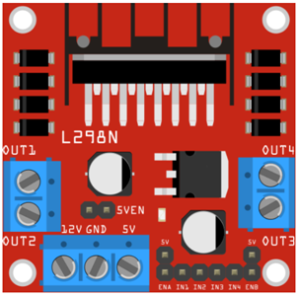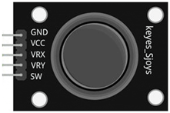

**+X**

**-Y**

**-X**

**+Y**

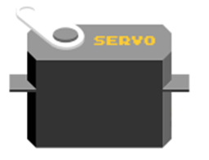

**+X**

**-Y**

**-X**

**+Y**

*Arrêt*

*400*

*100*

*0*

*600*

*900*

*1023*

*45°*

*0°*

*135°*

*180°*

*600*

*Arrêt*

*400*

*100*

*0*

*900*

*1023*

*Avant Faible*

*Av. Fort*

*Arrière Faible*

*Ar. Fort*



**+X**

**-Y**

**-X**

**+Y**

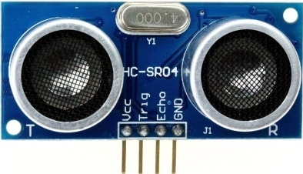

*Temps aller/retour*

*Trig*

*Echo*

*10µs*

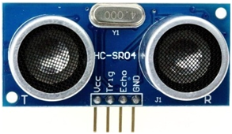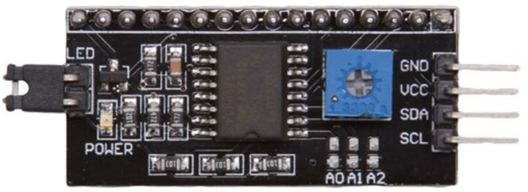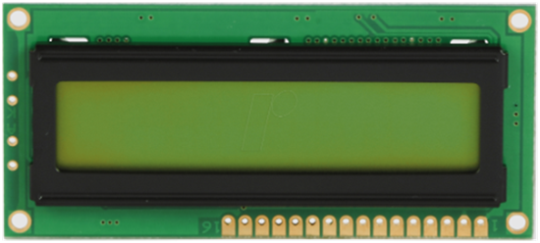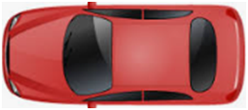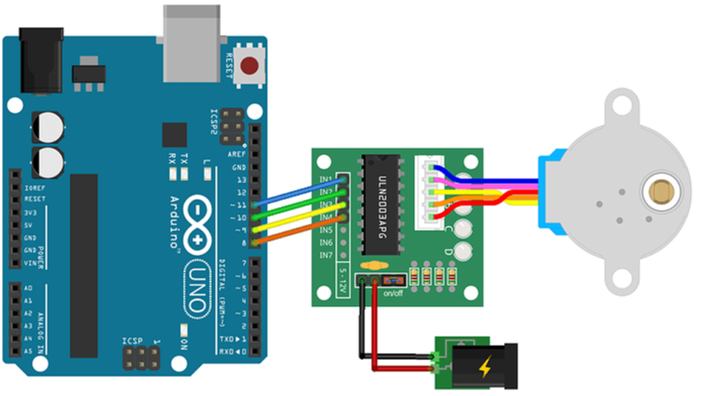

***5V***



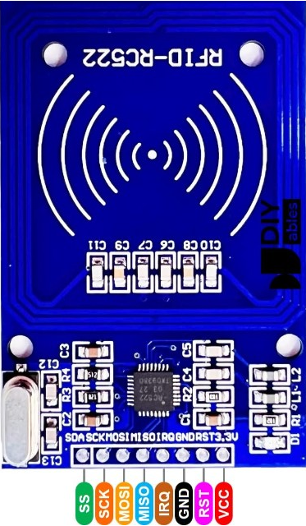

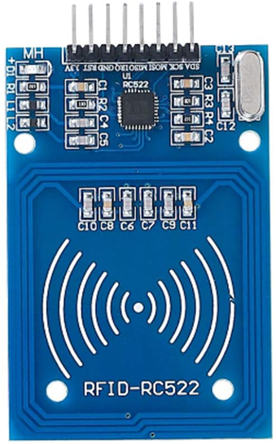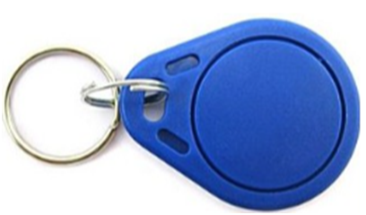

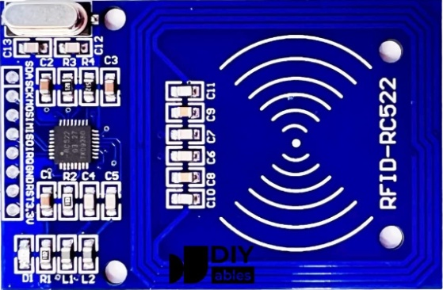



***Tag***

***Lecteur***

***Système de***

***traitement***

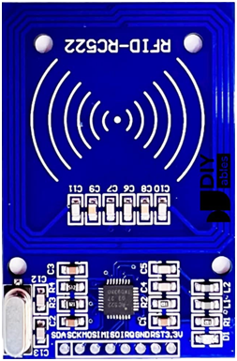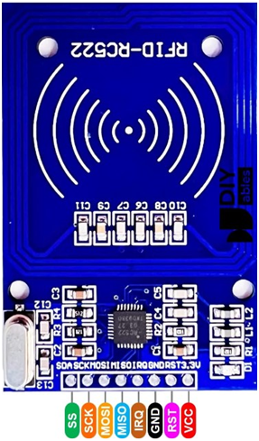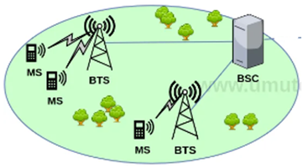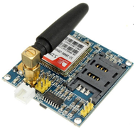

***GSM***

Interrompre action en cours (ESC)

Vérifier si le module répond aux commandes AT

Vérifier si le module est connecté au réseau GSM

Mode texte

Pas d'écho

Redémarrer le module

Envoyer message

*Oui*

*Non*

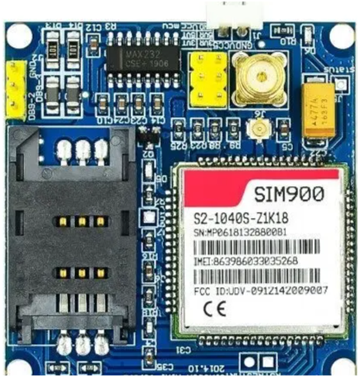

*5V*

*2A*



*12V*



*5V*

*2A*

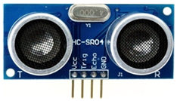

***Row()*** *-> Ligne*

***Column()*** *-> Colonne*

